Pragadiesh Palaniappan

Date of birth: 24/03/1994 Nationality: Indian

Address: 30/ NA,Siruvani Nadhi St, Madurai - 625014 Phone number: 9629253038

Email address: spragadiesh@yahoo.in

# Career Objective



Seeking a technically challenging position in the area of ETL as Ab Initio developer, providing a highly motivated, progressive and friendly environment, these allow the pursuit of career advancement and expand my knowledge and skills.

# Profile

Skilled Experience in Software Development Life Cycle (SDLC) and strong knowledge on agile methodology.

Possess good knowledge on data warehousing, ETL concepts and different stages of ETL process.

Expert in Control-M. (Batch monitoring tool)

Basic knowledge in scripting SQL queries in Teradata.

Proficient in creating graphs from source to target using various components in Ab Inito.

Finding the transformation logic as per the business requirement. Basic knowledge in ETL Admin and Unix Scripting.

Experienced in Teradata access management and Admin activity. Trained in Informatica, SSIS, SSRS and Tableau.

Improved working ability to handle the job independently and responsibly.

# Work Experience

08/2015 – present Bangalore, India / Durham, USA

## Software Development Senior Analyst

### NTT DATA Global Delivery Services Ltd

Project Title:

Blue Cross and Blue Shield of North Carolina (Health Insurance Domain)

Development of graphs based on design and requirement. Unit testing and defect fixes in development graph.

Worked in UAT team for graph testing and fixes and well trained in Control-M.

Single handedly completed UAT refresh project.

Worked on creating Automated SAS Reports.

Worked on Migration of SAS Codes to Ab Inito Graphs.

Responsible for meeting deadline and delivery.

Following all quality standard and Ab Inito best practices.

Lead a team of 10 members.

***Tools Used:*** Ab Inito, Teradata, Control-M, Unix, Tableau.

# Education



05/2009 – 04/2011



Madurai, India

## Science

### CEOA Public School

Passed out 12th grade with 78%

06/2011 – 04/2015



Salem, India

## B.Tech IT

### Sona College of Technology

Completed under graduation with 7.3 (CGPA)

# Skills



TOOLS

Control-M Ab Inito UNIX

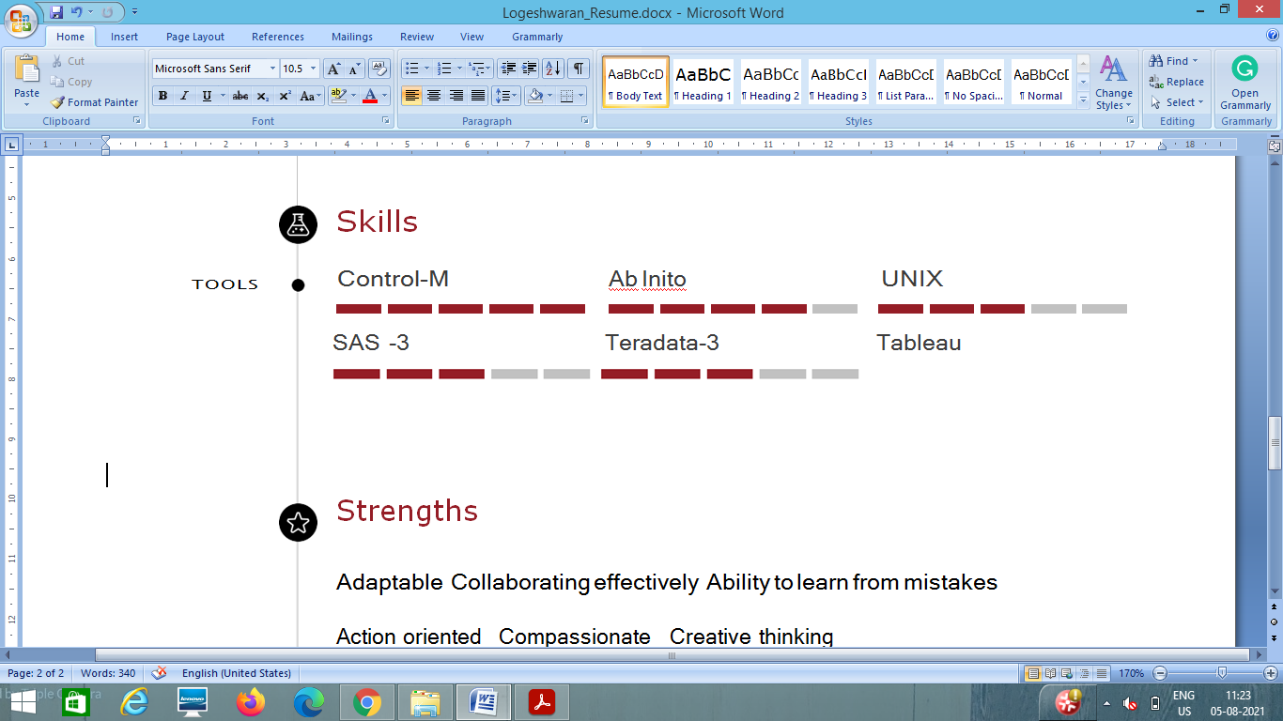 SAS Teradata Tableau

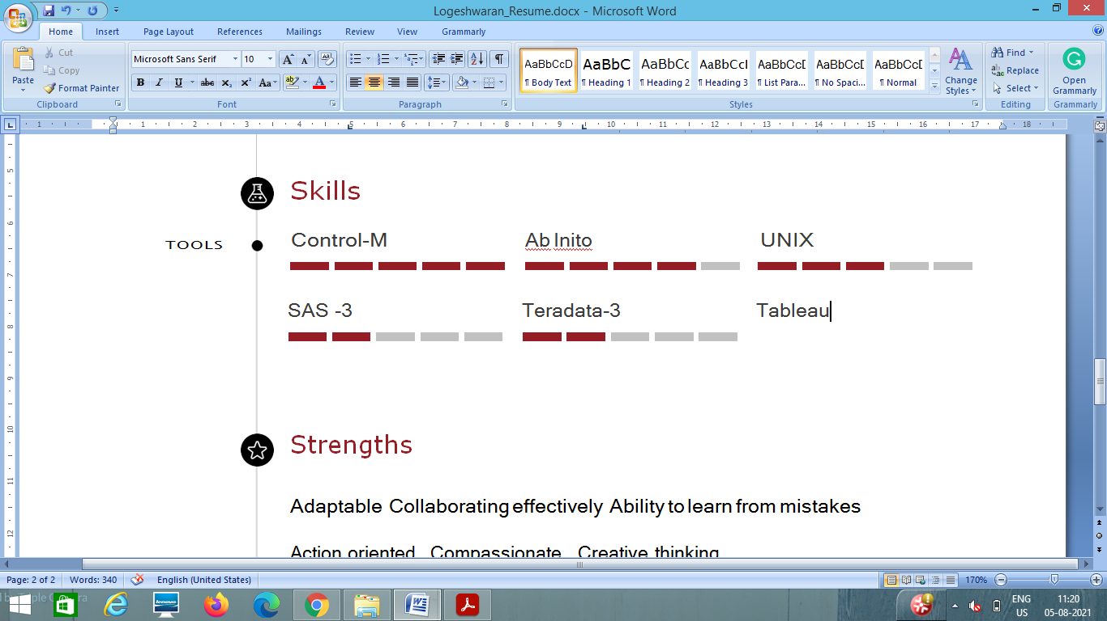

# Strengths

Adaptable Collaborating effectively Ability to learn from mistakes

Action oriented Compassionate Creative thinking

# References

7899706626

## Dinesh Dhanasekaran



### NTT Data

Project Manager

9900470707

Pramod NTT Data Team Lead

